Name – Megha Y RayanaGoudra

SRN – PES2UG22EC077

Single cycle RISC-V :

1. Instruction fetch

module mux_1 #(parameter N=32)(a,b,s,y);

input logic [N-1:0] a,b;

output logic [N-1:0]y;

input logic s;

assign y=s?a:b;

endmodule

module PC #(parameter N=32) (input logic clk,input logic rst,input logic [N-1:0] pc_next,output logic [N-1:0] pc);

always_ff@(posedge clk)

begin

if (rst)

pc<= 32'b0 ;

else

pc<= pc_next ;

end

endmodule

module instr_mem #(parameter W=32, L=1024) (addr,instr,reset);

initial

begin

$readmemh("program_dump.hex",mem);

end

input logic reset;

input logic [W-1:0] addr;

output logic [W-1:0] instr;

logic [W-1:0] mem [0:L-1];

assign instr=reset?0:mem[addr];

endmodule

module fulladder #(parameter N=32)(a,b,sum);

input logic [N-1:0] a,b;

output logic [N-1:0] sum;

assign sum=a+b;

endmodule

module instr_fetch #(parameter N=32) (input logic clk,input logic reset, input logic sel, input logic [N-1:0]pc_imm, output logic [N-1:0]pc_new,output logic [N-1:0]inst,pc);

wire [N-1:0]line1;

mux_1 #(32) g1(pc_new,pc_imm,sel,line1);

PC #(32) g2(clk,reset,line1,pc);

instr_mem #(32) g3(pc,inst,reset);

fulladder #(32) g4(pc,32'd4,pc_new);

endmodule

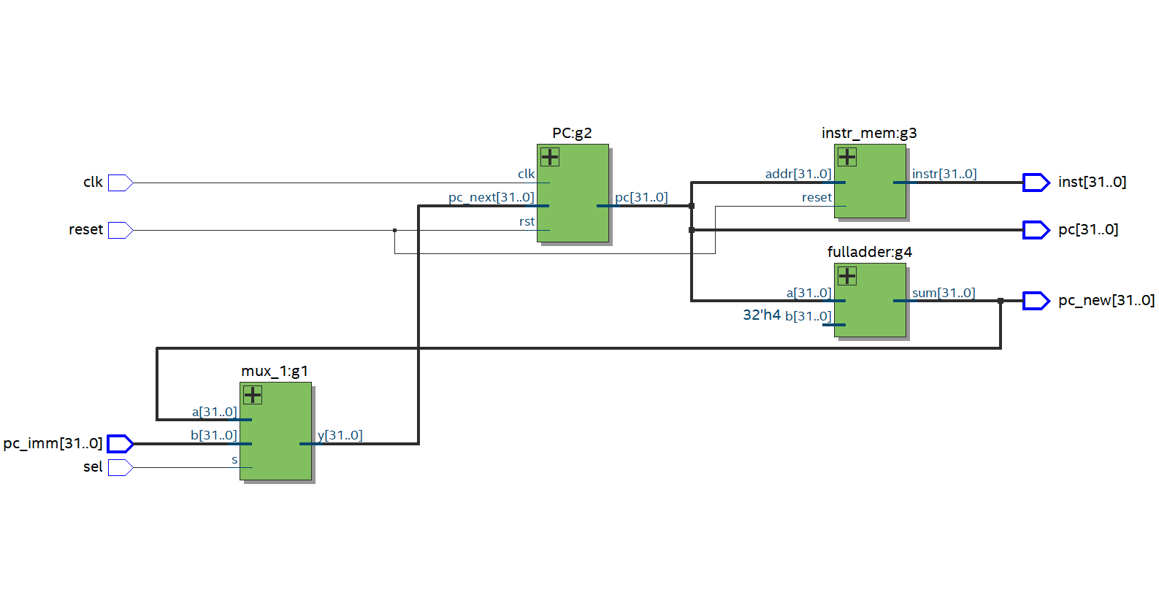

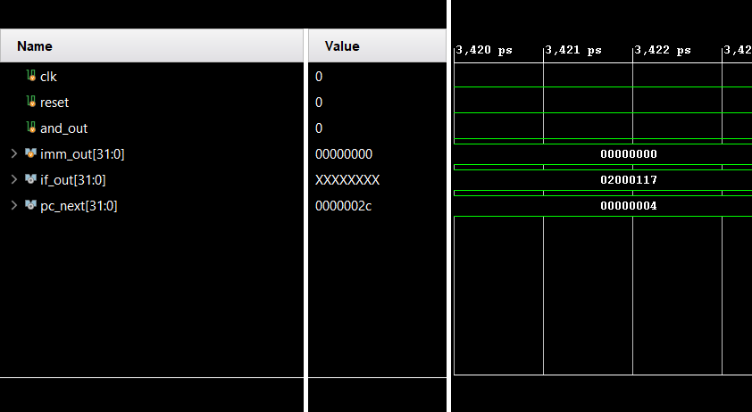

1. Instruction Decode

module decoder (input logic [31:0]inst, output logic [4:0]rd,output logic [4:0]rs1, output logic [4:0]rs2,output logic [2:0]func3, output logic [6:0]func7,output logic [11:0]imm,output logic [6:0]opcode);

always_comb

begin

rd = 5'b0;

rs1 = 5'b0;

rs2 = 5'b0;

func3 = 3'b0;

func7 = 7'b0;

imm = 12'b0;

opcode=inst[6:0];

case(inst[6:0])

7'b0110011:

begin

rd=inst[11:7];

rs1=inst[19:15];

rs2=inst[24:20];

func3=inst[14:12];

func7=inst[31:25];

end

7'b0010011:

begin

rd=inst[11:7];

rs1=inst[19:15];

func3=inst[14:7];

imm=inst[11:0];

end

7'b1100011:

begin

rs1=inst[19:15];

rs2=inst[24:20];

func3=inst[14:12];

imm={inst[31],inst[30:25],inst[11:8],inst[7]};

end

7'b0100011:

begin

rs1=inst[19:15];

rs2=inst[24:20];

func3=inst[14:7];

imm={inst[31:25],inst[11:7]};

end

7'b0000011:

begin

rd=inst[11:7];

rs1=inst[19:15];

func3=inst[14:7];

imm=inst[11:0];

end

endcase

end

endmodule

module regfile(input logic [4:0]rs1_addr,rs2_addr,rd_addr,input logic reg_write,input logic [31:0]wr_data, input logic reset,output logic [31:0]rs1_data,rs2_data);

logic [31:0]rfile[0:31];

always_comb

begin

if(~reset)

begin

rs1_data=rfile[rs1_addr];

rs2_data=rfile[rs2_addr];

end

else

begin

rs1_data=32'b0;

rs2_data=32'b0;

end

end

always_ff @(posedge reg_write or posedge reset) begin

if (reset) begin

for (int i = 0; i < 32; i++) begin

rfile[i] = 32'b0; // Clear all registers

end

end

else if (reg_write) begin

rfile[rd_addr] = wr_data; // Write data to the specified register

end

end

endmodule

module sign_exe (input logic [11:0]imm,output logic [31:0]imm_exe);

always_comb

begin

if(imm[11]==0)

begin

imm_exe[31:12]=20'b0;

imm_exe[11:0]=imm[11:0];

end

else

begin

imm_exe[31:12]=20'b1;

imm_exe[11:0]=imm[11:0];

end

end

endmodule

module instr_decode (

input logic [31:0] inst,

output logic [31:0] rs1_data,

output logic [31:0] rs2_data,

output logic [31:0] imm32,

output logic [6:0] func7,

output logic [2:0] func3,

input logic [31:0] wr_data,

input logic reset,

output logic [6:0]opcode

);

wire [4:0] rs1_addr;

wire [4:0] rs2_addr;

wire [4:0] rd_addr;

wire [11:0] imm12;

wire regwrite;

decoder g1(inst,rd_addr,rs1_addr,rs2_addr,func3,func7,imm12,opcode);

regfile g2(rs1_addr,rs2_addr,rd_addr,regwrite,wr_data,reset,rs1_data,rs2_data);

sign_exe g3(imm12,imm32);

endmodule

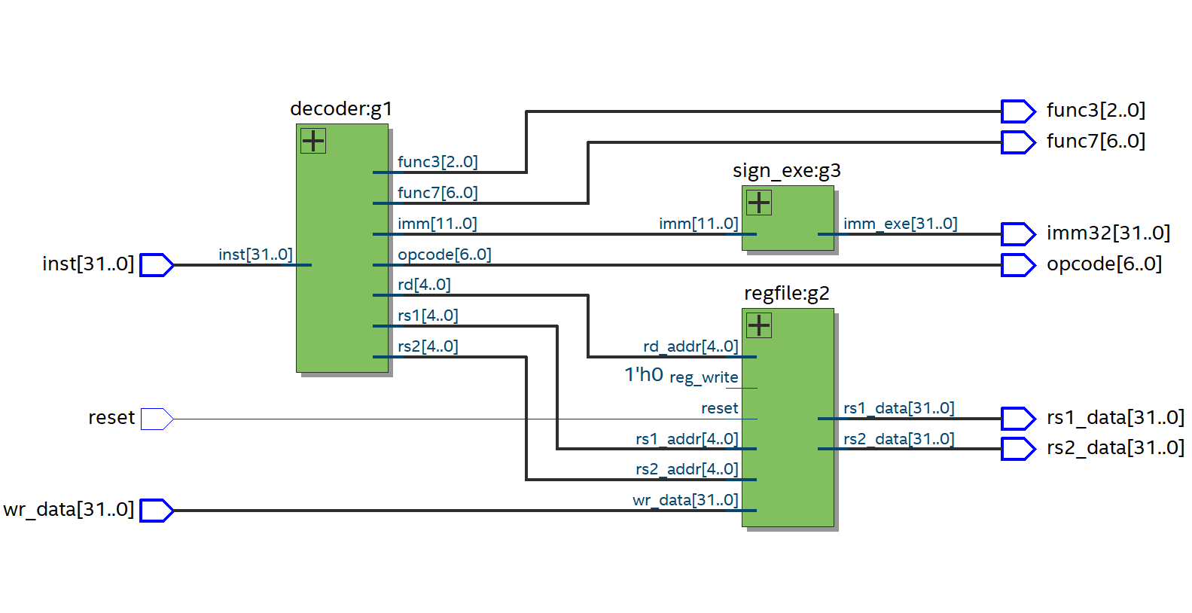

1. Instruction Execution

module alu #(parameter N=32)(input logic [N-1:0]rs1_data,rs2_data,input logic alu_op, output logic [N-1:0]alu_result,output logic zero);

always_comb

begin

case(alu_op)

4'b0000: alu_result=rs1_data&rs2_data;

4'b0001: alu_result=rs1_data|rs2_data;

4'b0010: alu_result=rs1_data+rs2_data;

4'b0110: alu_result=rs1_data-rs2_data;

endcase

if(alu_result==0)

zero=1;

else

zero=0;

end

endmodule

module and_gate(input logic a, input logic b, output logic q);

assign q=a&b;

endmodule

module instr_exec #(parameter N=32) (input logic [N-1:0]rs1_data,rs2_data,imm,pc,input logic alusrc,branch,input logic alu_op,output logic [N-1:0]alu_result,pc_imm,output logic and_result);

wire [N-1:0]mux_result,imm32_new;

wire zero;

mux_1 g1(rs2_data,imm,alusrc,mux_result);

alu g2(rs1_data,mux_result,alu_op,alu_result,zero);

and_gate g3(zero,branch,and_result);

assign imm32_new = imm<<1;

fulladder g8(imm32_new,pc,pc_imm);

endmodule

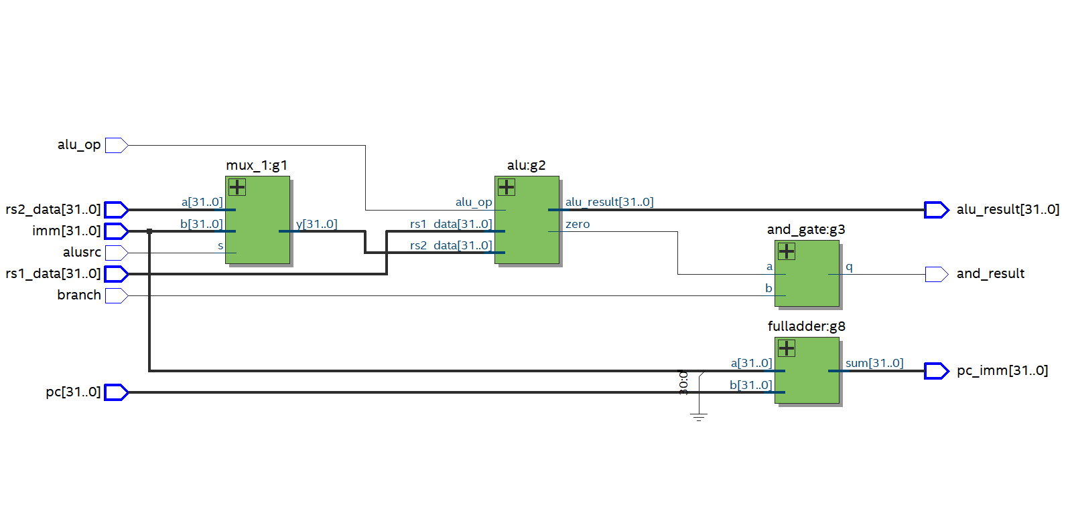

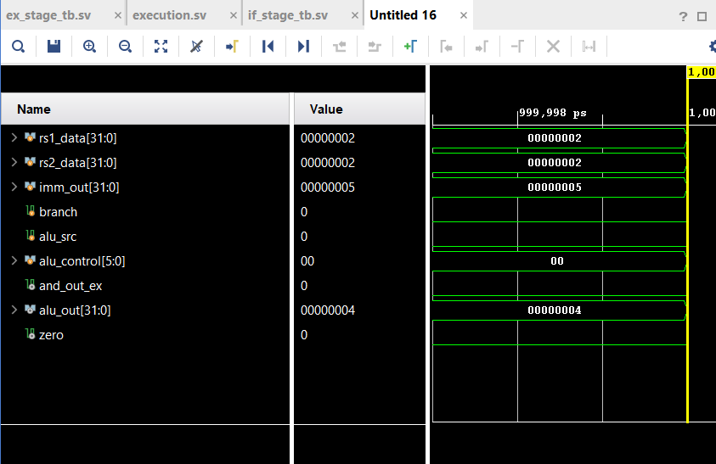

1. Memory Access

module memstage #(parameter N=32, M=1024) (

input logic [N-1:0] alu_out, data_in,

input logic mem_read, mem_write,

output logic [N-1:0] data_out

);

logic [N-1:0] mem [0:M-1];

always_comb

begin

if( mem_read==1 && mem_write==0)

data_out= mem[alu_out];

else if (mem_read==0 && mem_write==1) begin

mem[alu_out]= data_in;

data_out= 32'b0;

end

else

data_out= 32'b0;

end

endmodule

module data_mem #(parameter N=32) (

input logic [N-1:0] alu_out, data_in,

input logic mem_read, mem_write,

output logic [N-1:0] data_out

);

memstage g1(alu_out, data_in,mem_read, mem_write,data_out);

endmodule

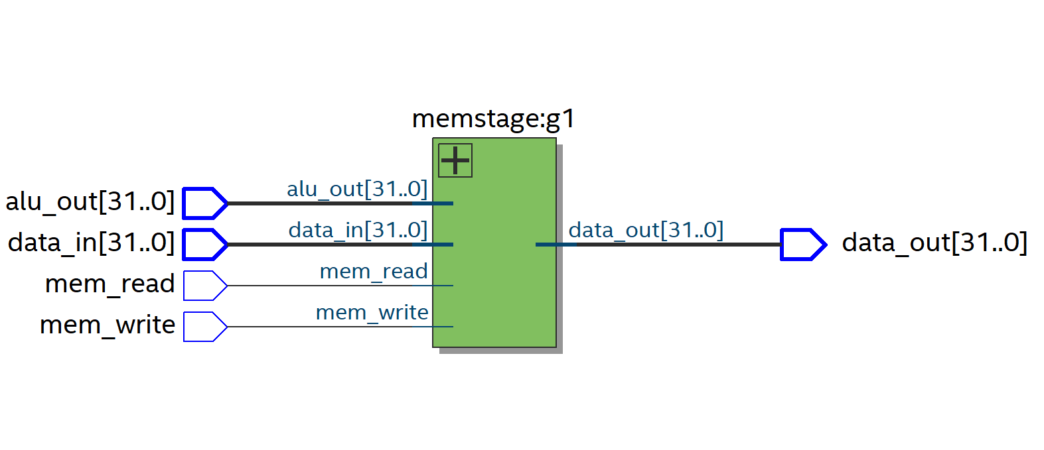

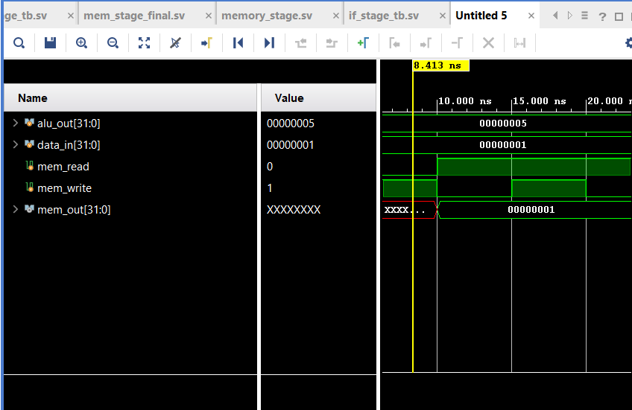

1. Write Back

module write_back1 #(parameter N=32)(

input logic [N-1:0] alu_result,

input logic [N-1:0] data_out,

input logic mem_reg,

output logic [N-1:0] wr_data

);

(.alu_result(alu_result),.data_in(data_in),.mem_read(mem_read),.mem_write(mem_write),.data_out(data_out));

mux_1 wb_mux (alu_result,data_out,mem_reg,wr_data);

endmodule

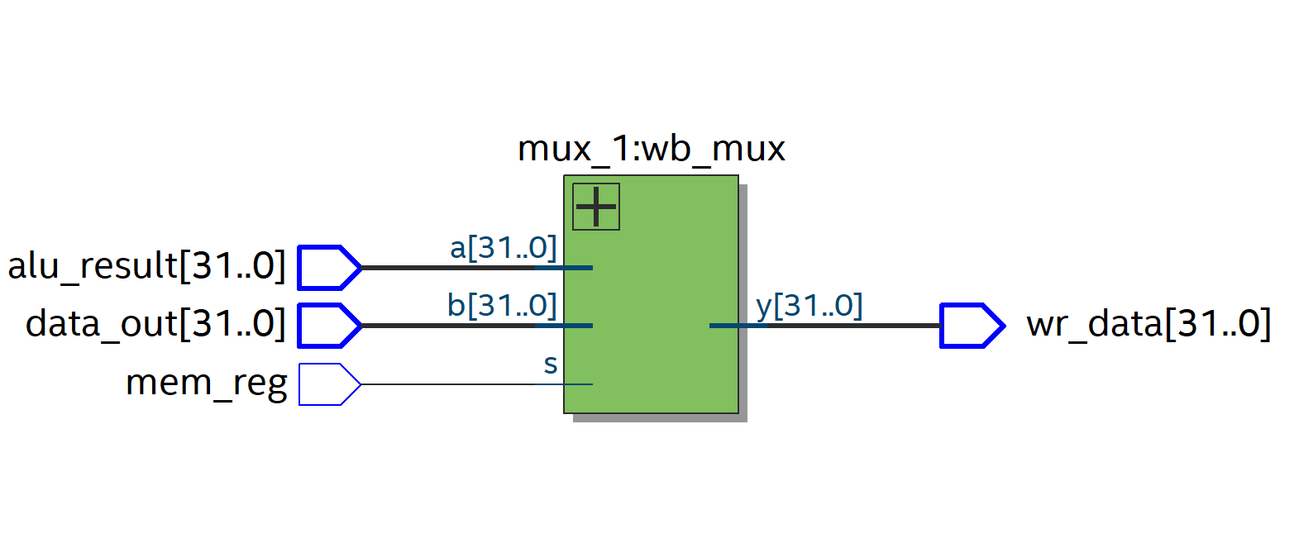

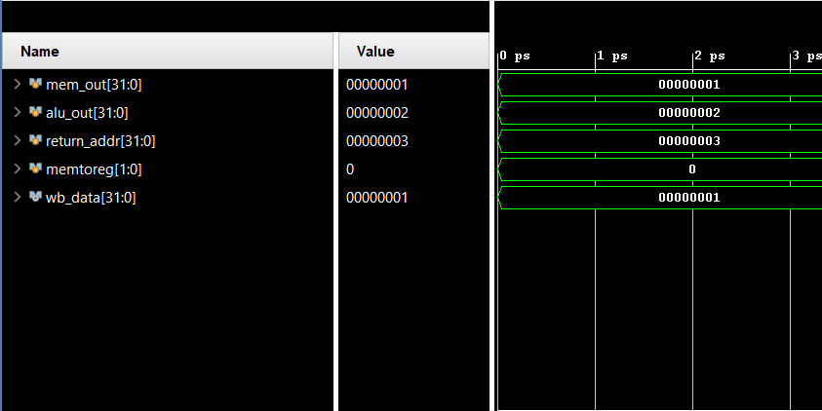

1. Main Control Unit

module Main_control(input logic [6:0] opcode,

output logic regWrite, output logic ALUSrc,

output logic memRead,

output logic memWrite,

output logic branch,

output logic [1:0] ALUOp, output logic mem_reg

);

always_comb begin

regWrite = 0;

mem_reg=0;

ALUSrc = 0;

memRead = 0;

memWrite = 0;

branch = 0;

ALUOp = 2'b00;

case (opcode)

7'b0110011: begin // R-type instructions

regWrite = 1;

ALUOp = 2'b10;

end

7'b0010011: begin // I-type instructions

regWrite = 1;

ALUSrc = 1;

ALUOp = 2'b00;

end

7'b0000011: begin // Load instructions

regWrite = 1;

memRead = 1;

ALUSrc = 1;

mem_reg=1;

end

7'b0100011: begin // Store instructions

memWrite = 1;

ALUSrc = 1;

end

7'b1100011: begin // Branch instructions

branch = 1;

ALUOp = 2'b01;

end

default: begin

regWrite=0;

ALUSrc=0;

memRead=0;

memWrite=0;

branch=0;

ALUOp=0;

end

endcase

end

endmodule

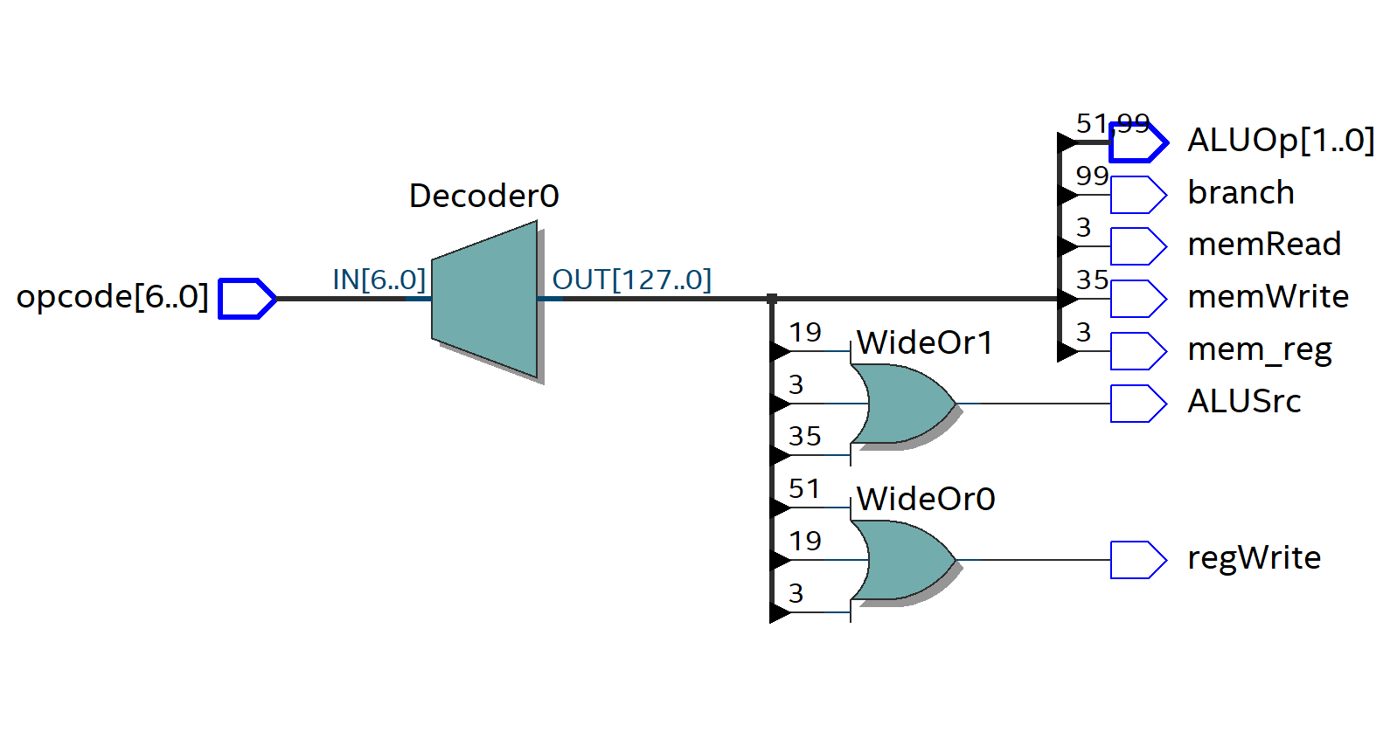

1. ALU Control Unit

module Alu_control( input logic [1:0] ALUOp,

input logic [2:0] funct3,

input logic funct7_5,

output logic [3:0] ALUControl

);

always_comb begin

ALUControl = 4'b1111;

if (ALUOp == 2'b00) begin

ALUControl = 4'b0010; // ADD

end

else if (ALUOp == 2'b01) begin

ALUControl = 4'b0110; // SUB

end

else if (ALUOp == 2'b10) begin

case (funct3)

3'b000: ALUControl = funct7_5 ? 4'b0110 : 4'b0010; // SUB if funct7_5=1, ADD if funct7_5=0

3'b111: ALUControl = 4'b0000; // AND

3'b110: ALUControl = 4'b0001; // OR

default: ALUControl = 4'b1111; // Undefined

endcase

end

end

endmodule

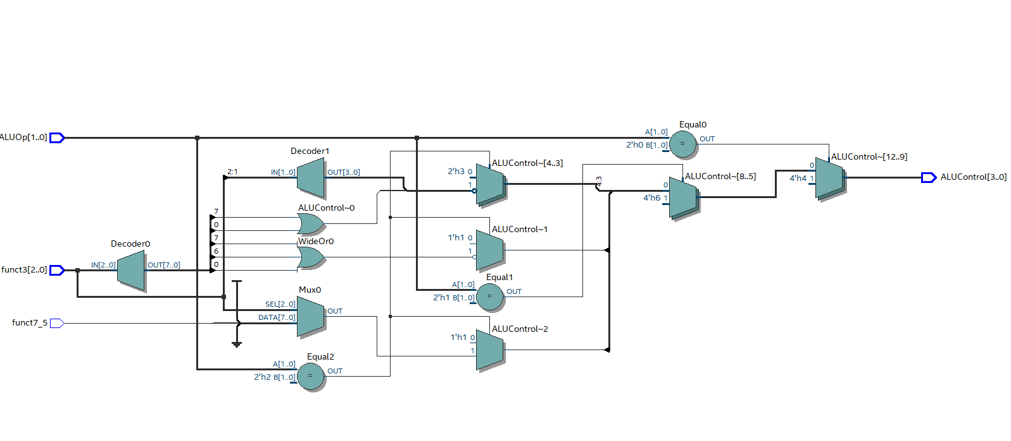

1. Top Module

module single_cycle #(parameter N=32) (input logic clk,reset);

logic [N-1:0]inst,pc_new,data_in,data_out, alu_out,wd;

logic [2:0] func3;

logic [6:0] func7,opcode;

logic [31:0]imm32_new,adder_out;

logic [31:0]imm32;

logic [31:0]wr_data;

logic [3:0]alu_op;

logic branch,alu_src,mem_read, mem_write,mem_reg,sel;

logic [31:0]rs1, rs2;

logic [N-1:0] pc_imm;

logic [N-1:0] pc;

logic reg_write;

logic [1:0] alu_control;

instr_fetch g1 (clk,reset,and_result,pc_imm,pc_new,inst,pc);

instr_decode g2(inst,rs1,rs2,imm32,func7,func3,wr_data,reset,opcode);

instr_exec g3(rs1,rs2,imm32,pc,alu_src,branch,alu_control,alu_out,pc_imm,and_result);

data_mem g4(alu_out, rs2,mem_read, mem_write,data_out);

write_back1 g5(alu_out,data_out,mem_reg,wr_data);

Main_control g9(opcode,reg_write,alu_src,mem_read,mem_write,branch,alu_op,mem_reg);

Alu_control g10(alu_op,func3,func7,alu_control);

endmodule

